FACULTY EVALUATION
Programme Name: Social Entrepreneurship Development Program (SEDP)- Advance Tanzania (2nd February - 6th February 2026)
Session: Funding Sources
Faculty Name: Tim Kipchumba
No. of Respondents: 16
No. of Participants: 16
Evaluation Parameter | (%) Individual Score | (%) Programme Average
Punctuality (Commencement and Completion of Sessions) | 97 | 95
How well do you understand the core concepts presented? | 92 | 90
Rate your confidence in applying the new skills learnt | 97 | 91
Degree of Faculty preparedness for the sessions | 95 | 94
Content and methodology of the program | 95 | 94
Quality of class and group discussions | 95 | 92
The information presented in the course is relevant to my work (ministry) | 95 | 94
Average scores | 95 | 93

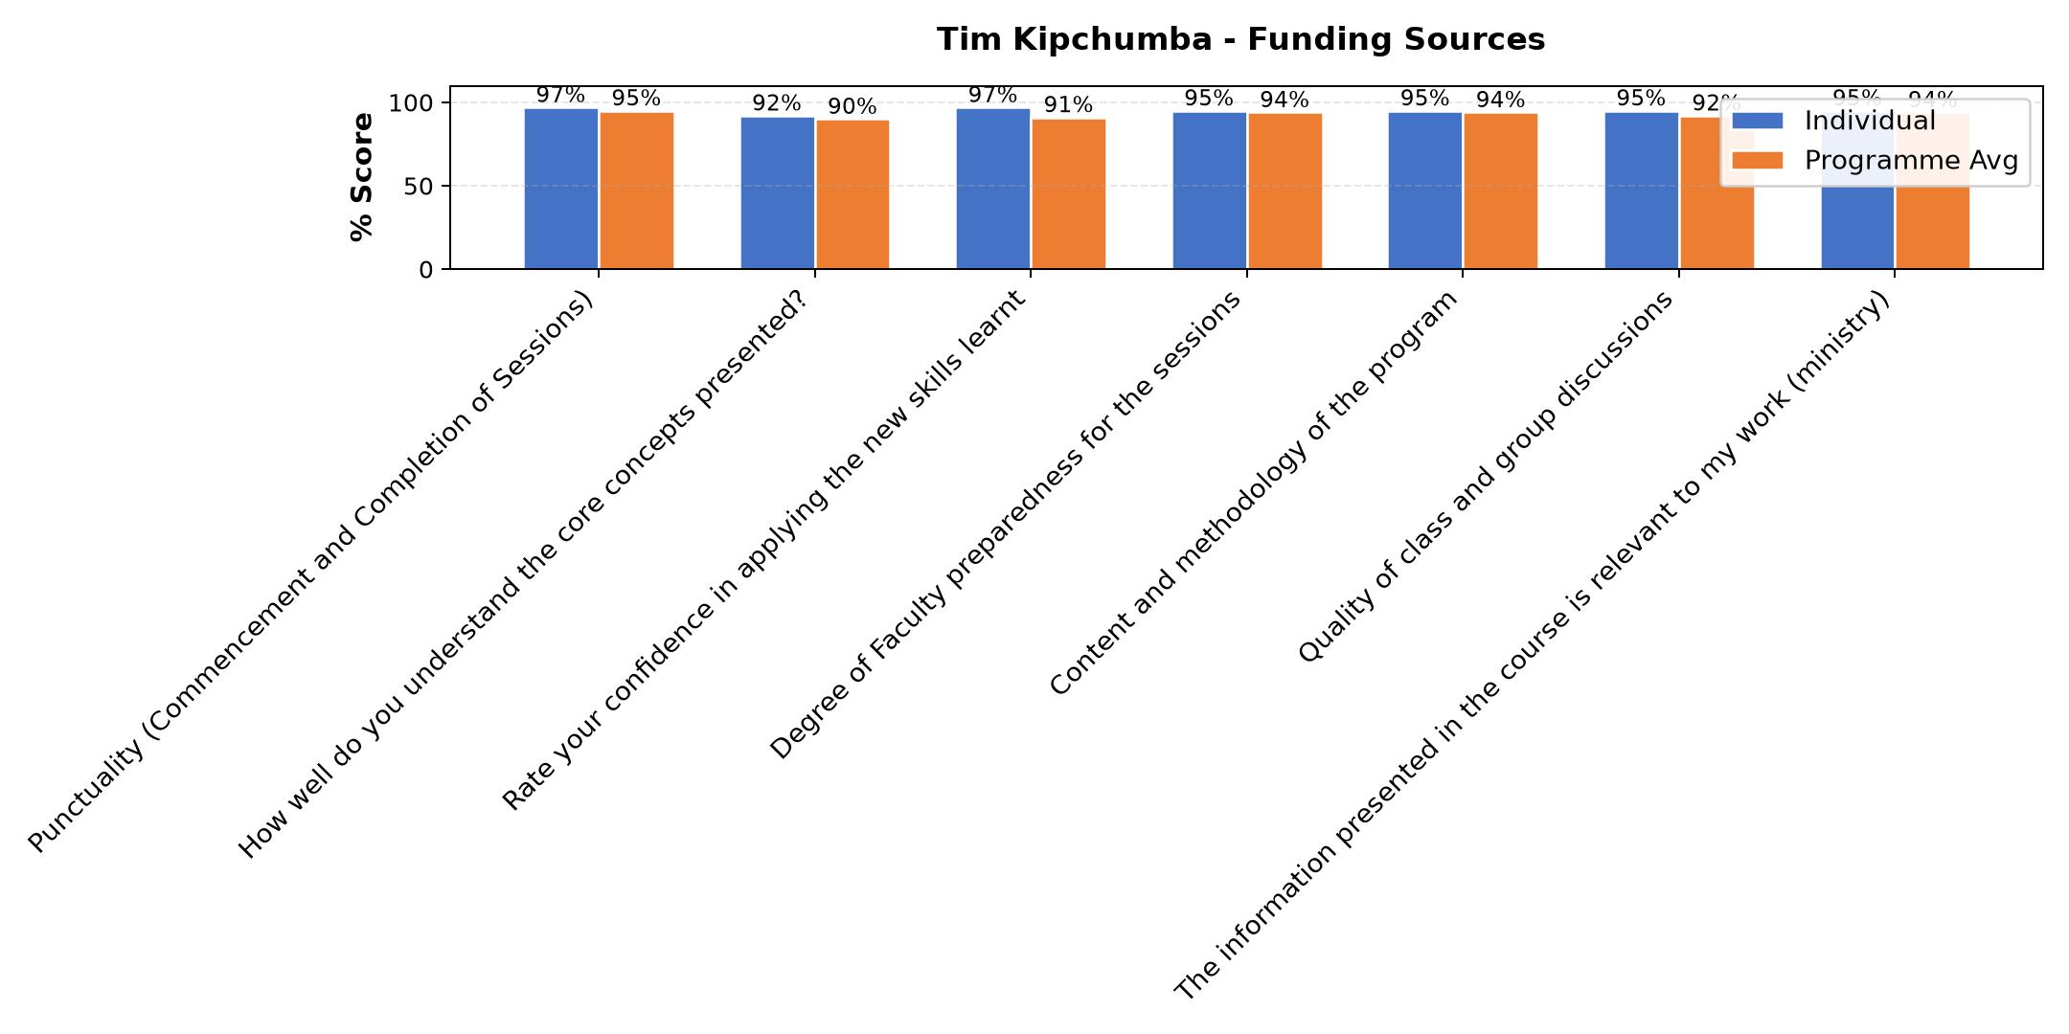

Comments & Feedback
- • I don't have donor addresses
- • Nil
- • It might be lacking the commitment to work on this given task
- • Thanks
- • Somo limefundishwa vizuri
- • Ana uzoefu mzuri .
- • Amewasilisha kwa kiwango halisi.
- • Amefundisha vizuri sana
- • How to write project and to meet the funding sources
- • Nimejifunza mambo yafutayo.
Vyanzo vya ufadhili.
b.sababu za kutafuta ufadhili.
C.tunawezaje kuimarisha uaminifu wetu.
D.uahitaji fedha kiasi gani?.
E.wawejezaji wanataka nini.
F.wawekezaji hataki nini.
Ninatakiwa niwe na hoja yenye mvuto na inayoshawishi.
- • No barriers
SUBMITTED THROUGH:
SBS Evaluation Automation System

